**MIT School of Computing.**

**Department of Information Technology**

**Project Synopsis**

**Group ID:SY_IT_03**

**Project Title: EduStake: Centralized College Resource Sharing Platform**

**Group Members:**

|  |  |  |  |  |
| --- | --- | --- | --- | --- |
| **Enrollment Number** | **Roll No.** | **Name of student** | **Email Id** | **Contact Number** |
| **ADT23SOCB1630** | **61** | **Sahil Jirapure** | **sahiljirapure8@gmail.com** | **8888955675** |
| **ADT23SOCB1509** | **05** | **Anurag Bodkhe** | **Bodkheanurag235@gmail.com** | **9022977272** |
| **ADT23SOCB1629** | **60** | **Ujjwalkumar Nitin Garud** | **Garudujjwal@gmail.com** | **9766499137** |
| **ADT23SOCBD207** | **67** | **Shreenivas bhore** | **Shreenivasbhore@gmail.com** | **8080343362** |

**Problem Statement:** In many educational institutions, students and faculty struggle to efficiently share and access academic resources such as lecture notes, research papers, e-books, assignments, project materials, and other study materials. Traditional methods like emails, social media groups, and offline sharing are inefficient, leading to disorganized content, difficulty in retrieving specific resources, and lack of proper access control.

**Abstract:** The **EduStake: Centralized College Resource Sharing Platform** is a **web-based system** that allows students, faculty, and admins to **upload, search, download, and manage academic resources** efficiently. It features **role-based access, version control, search filters, feedback options, and notifications**, ensuring seamless **collaborative learning and secure resource management**.

**Literature Survey: Detail survey done**

**Proposed System (Block Diagram):**

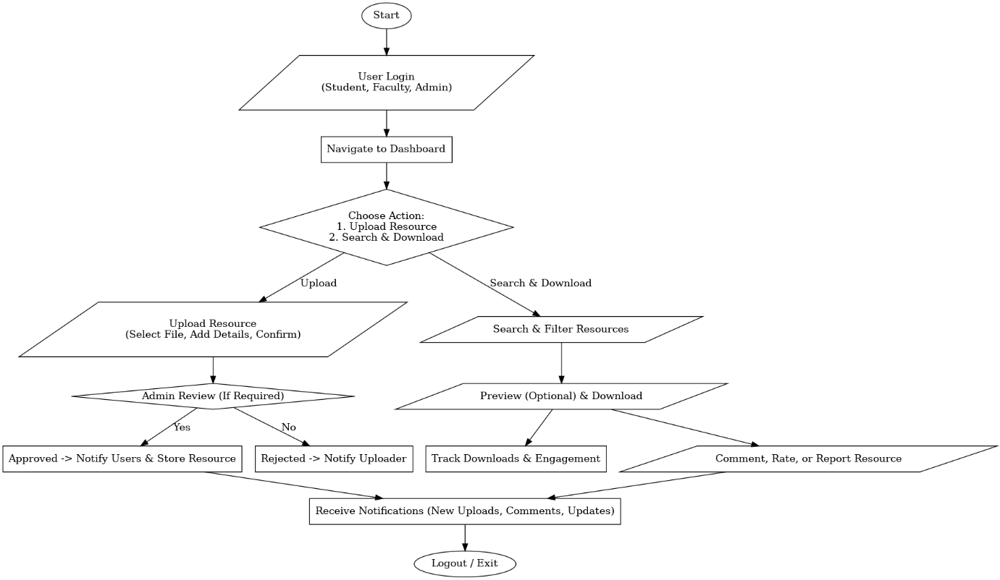

**Conclusion:** The College Resource Sharing Platform enhances academic collaboration by providing a centralized, secure, and accessible repository for students and faculty. With efficient resource management, role-based access, and interactive features, it streamlines learning and ensures seamless knowledge sharing. By fostering engagement and accessibility, the platform contributes to a more efficient and connected educational environment.

**References:** • Academic Resource Management Systems – A Review of Best Practices. *Journal of Educational Technology*, 2023.

• Cloud-Based Learning Platforms for Higher Education. *IEEE Xplore*, 2022.

• Digital Libraries and Resource Sharing in Colleges. *Springer Education Research*, 2021.

• Role-Based Access Control in E-Learning Systems. *ACM Digital Library*, 2020.

• Enhancing Collaboration in Higher Education Through Online Resource Sharing. *International Journal of Education & Development*, 2019.

|  |  |  |
| --- | --- | --- |
| **Project Approval team** | **Remark** | **Sign** |
| Guide |  |  |
| SY Project Coordinator |  |  |
| AMC Head: Prof. Reetika Kerketta |  |  |
| Secretary/ Project Coordinators:  Prof. Jyoti Nandimath |  |  |
| **HOD**:  Prof. Dr. Prashant Dhotre |  |  |